StatefulSet With Sync Enabled, Automatic Failover Measures , Data Persistence Enabled
Add Percona Helm repo
helm repo add percona https://percona.github.io/percona-helm-charts/
helm repo update
Create Namespace Webapps
kubectl create ns webapps
Setup Storage Class For The Project
# StorageClass for AWS EBS
apiVersion: storage.k8s.io/v1
kind: StorageClass
metadata:
name: ebs-sc
provisioner: ebs.csi.aws.com
parameters:
type: gp3
fsType: ext4
reclaimPolicy: Retain
volumeBindingMode: WaitForFirstConsumer

Install Required CRDs (MANDATORY)
kubectl apply -f https://raw.githubusercontent.com/percona/percona-xtradb-cluster-operator/main/deploy/crd.yaml
kubectl apply -f https://raw.githubusercontent.com/percona/percona-xtradb-cluster-operator/main/deploy/bundle.yaml -n webapps

Install the Percona Operator (MANDATORY)
Run the following:
🔹 Step 1: Install Operator (Helm Method)
helm install percona-operator percona/pxc-operator --namespace webapps
This installs the Kubernetes controller/operator which watches for PerconaXtraDBCluster resources and spawns the actual pods.
🔹 Step 2: Verify Operator Is Running
kubectl get pods -n webapps

Create Values Yaml For Percona DB Cluster
---
crVersion: 1.10.0
secrets:
name: my-db-secrets
ssl:
enabled: false
pxc:
size: 3
image:
repository: percona/percona-xtradb-cluster
tag: 8.0.41-32.1
persistence:
enabled: true
accessMode: ReadWriteOnce
storageClass: ebs-sc
size: 5Gi
haproxy:
enabled: true
proxysql:
enabled: false
logcollector:
enabled: false
backup:
enabled: false

# Install Percona DB Cluster Using Helm
helm install percona-db percona/pxc-db -n webapps -f pxc-values.yaml
# Get Mysql Root Password
ROOT_PASSWORD=$(kubectl -n webapps get secret percona-db-pxc-db-secrets -o jsonpath="{.data.root}" | base64 --decode)
echo $ROOT_PASSWORD

kubectl exec -it <PODNAME> -n webapps – bash
mysql -u root -p
CREATE DATABASE bankappdb;
CREATE USER 'appuser'@'%' IDENTIFIED BY 'appuser123';
GRANT ALL PRIVILEGES ON bankappdb.* TO 'appuser'@'%';
FLUSH PRIVILEGES;

STATUS CHECK
#!/bin/bash

NAMESPACE="webapps"
PODS=("percona-db-pxc-db-pxc-0" "percona-db-pxc-db-pxc-1" "percona-db-pxc-db-pxc-2")

# Get root password
ROOT_PASSWORD=$(kubectl get secret percona-db-pxc-db-secrets -n $NAMESPACE -o jsonpath="{.data.root}" | base64 --decode)

for POD in "${PODS[@]}"; do
echo "🔹 Checking: $POD"
kubectl exec -n $NAMESPACE -i $POD -c pxc -- mysql -uroot -p"$ROOT_PASSWORD" -e "
SELECT 'Hostname' AS Metric, @@hostname AS Value;
SHOW STATUS LIKE 'wsrep_cluster_status';
SHOW STATUS LIKE 'wsrep_cluster_size';
SHOW STATUS LIKE 'wsrep_cluster_state_uuid';
SHOW STATUS LIKE 'wsrep_local_index';
SHOW STATUS LIKE 'wsrep_local_state_comment';
"
echo "--------------------------------------------------"
done

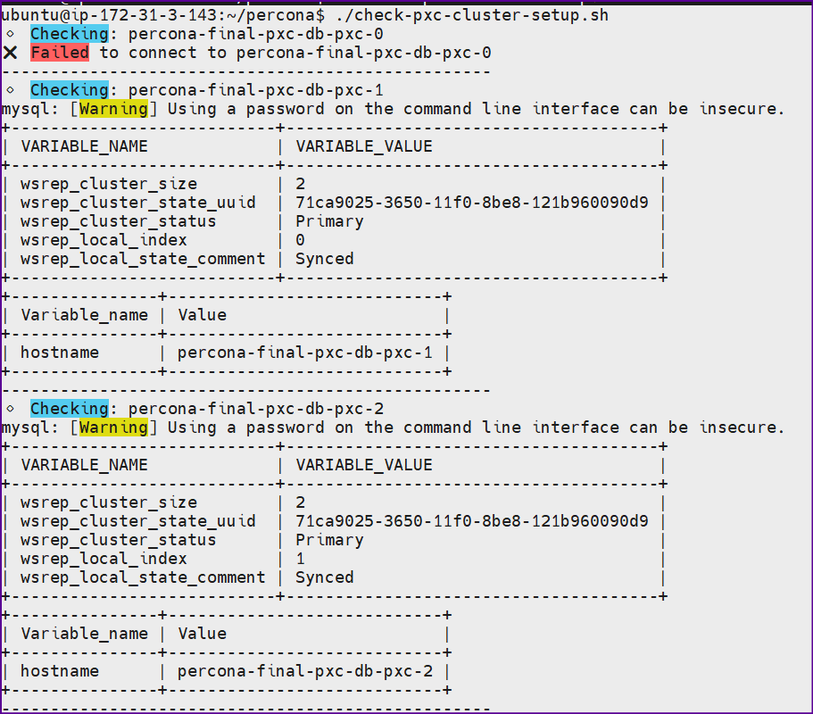
BANKAPP YAML MANIFEST
---
apiVersion: v1
kind: Secret
metadata:
name: mysql-secret
namespace: webapps
type: Opaque
stringData:
MYSQL_USERNAME: appuser
MYSQL_PASSWORD: appuser123

---
apiVersion: apps/v1
kind: Deployment
metadata:
name: bankapp
namespace: webapps
spec:
replicas: 1
selector:
matchLabels:
app: bankapp
template:
metadata:
labels:
app: bankapp
spec:
containers:
- name: bankapp
image: adijaiswal/bankapp:v6
ports:
- containerPort: 8080
env:
- name: SPRING_DATASOURCE_URL
value: jdbc:mysql://percona-db-pxc-db-haproxy.webapps.svc.cluster.local:3306/bankappdb?allowPublicKeyRetrieval=true&useSSL=false&serverTimezone=UTC
- name: SPRING_DATASOURCE_USERNAME
valueFrom:
secretKeyRef:
name: mysql-secret
key: MYSQL_USERNAME
- name: SPRING_DATASOURCE_PASSWORD
valueFrom:
secretKeyRef:
name: mysql-secret
key: MYSQL_PASSWORD

---
apiVersion: v1
kind: Service
metadata:
name: bankapp-service
namespace: webapps
spec:
type: LoadBalancer
selector:
app: bankapp
ports:
- port: 80
targetPort: 8080
